SETTING UP ENVIRONMENT DOCKER CLI INSTALLATION

|  |  |
| --- | --- |
| Team ID | PNT2022TMID17805 |
| Project Name | Customer Care Repository |
| Team Members | Abishek L, Athista Lakshmi  Bala Murugan G, Harshini |

**Step 1:** To start with Docker installation check the official website for installation setup: <https://docs.docker.com/get-docker/>

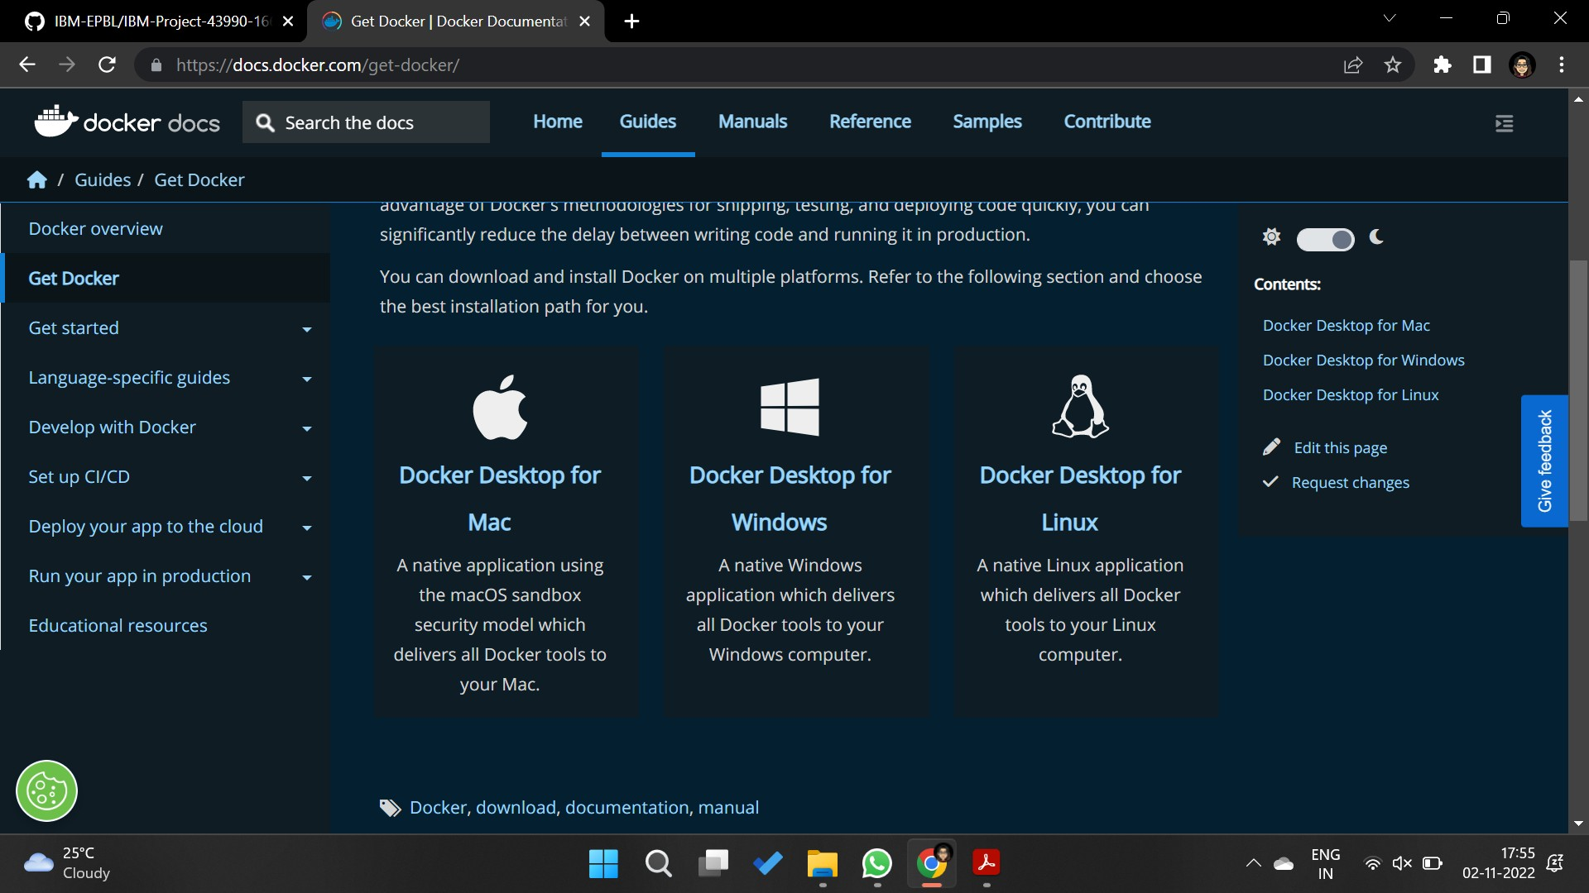

**Step 2:**Run the installation (which might take a while) and open the Docker Desktop Software

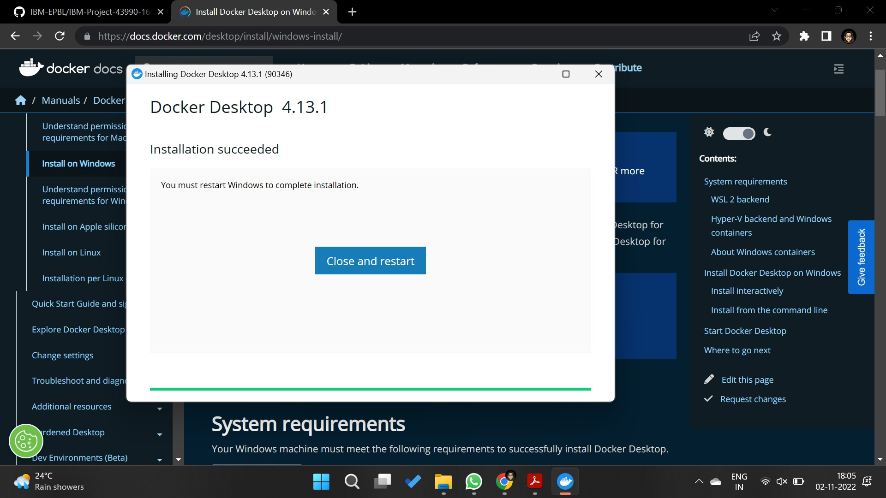

**Step 3:**Now while starting accept the terms and conditions and wait until docker starts

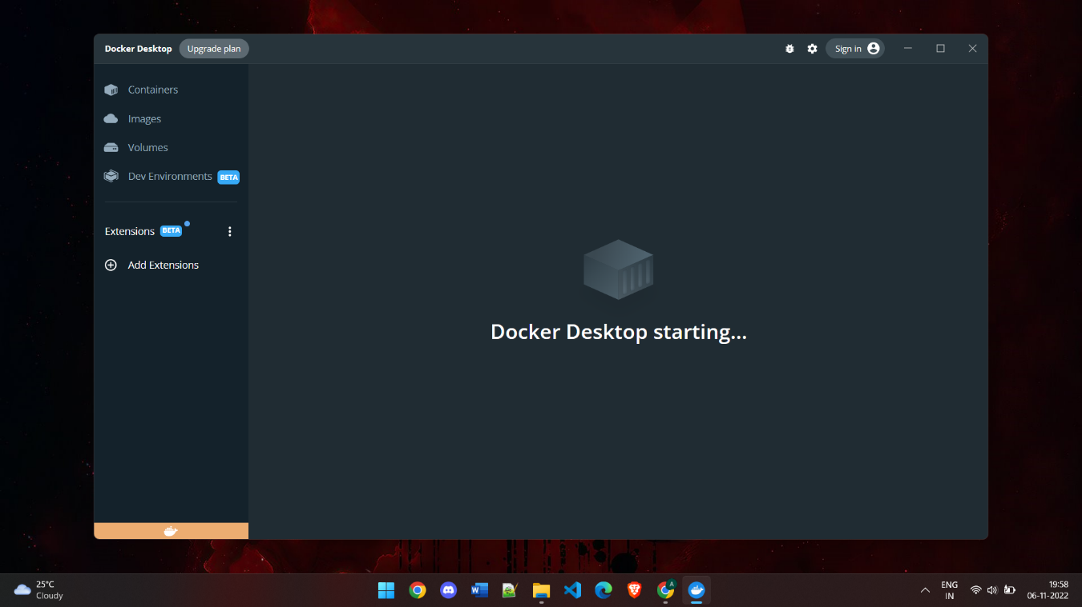

**Step 4:**Sometimes while trying to access any features an error box can be seen asking to install updated verison of Linux at <https://learn.microsoft.com/en-us/windows/wsl/install> for proper functioning, so proceed with the WSL setup.

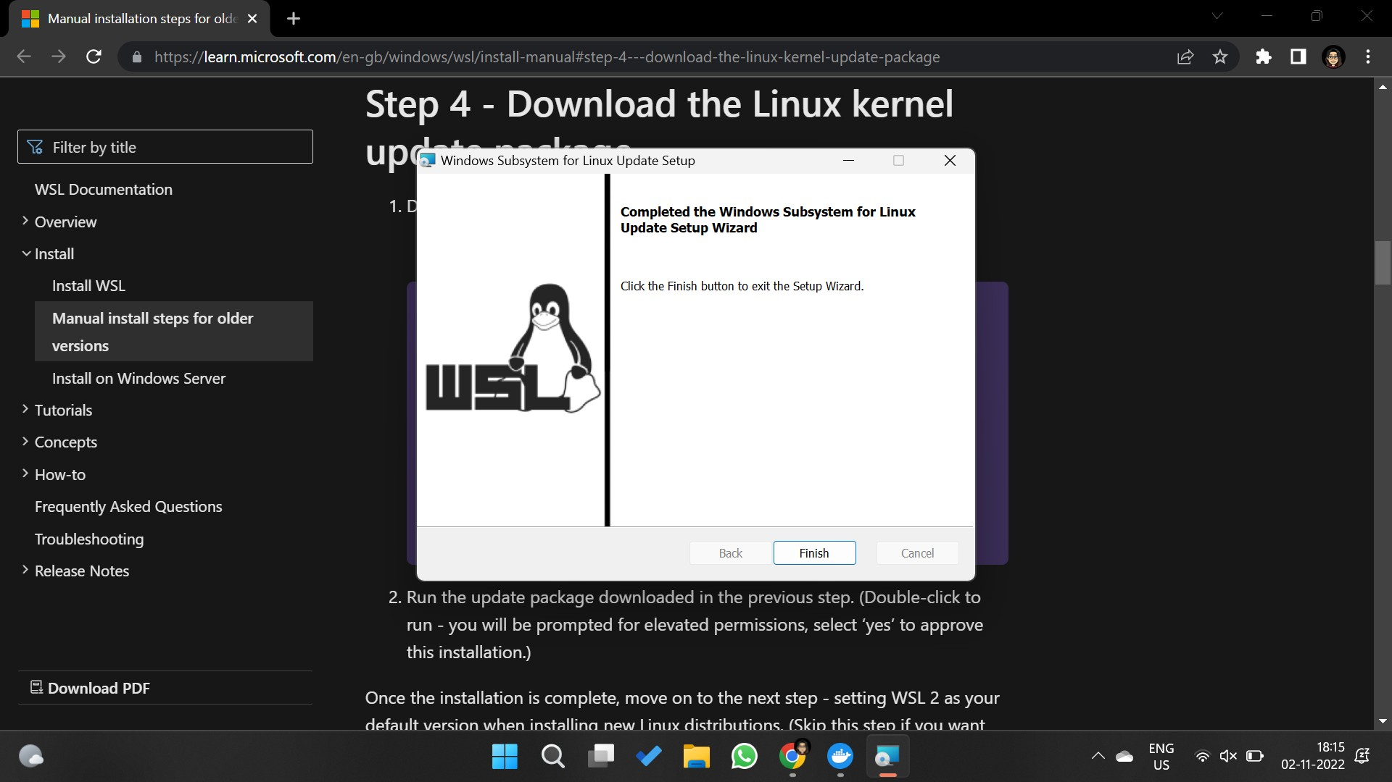

**Step 5:**Once done restart your system and try accessing docker features now Docker is successfully installed and ready to work.

